PERC Marketing Kit
Pittsburgh Education Recruitment Consortium 2023 Education Job Fair
Contents

PERC Overview 2
Consortia Member Colleges and Universities 2
PERC 2023 Education Job Fair Information 3
Date and location 3
Registration link 3
Registration Information 3
Eligibility 3
Social Media Marketing Materials 4
Tweets 4
Instagram Graphics 4
Facebook Graphics 5
Membership Workshop Opportunity 6
Marketing Emails 7
Member Schools 7
Candidates – Current Students 9
Candidates – Alumni 11
Faculty 13
Workshop Marketing Email 14
FACULTY ONLINE WORKSHOP 14

PERC Overview
The Pittsburgh Education Recruitment Consortium (PERC) is a consortium of approximately 26 colleges and universities in western Pennsylvania, Ohio and northern West Virginia. Annually, approximately 1000 candidates from the consortium (and several non-consortium institutions) attend the PERC Education Job Fair. Participating employers interview and hire teacher candidates in all Pre K-12 disciplines, as well as related professional certification areas such as school counseling, school social work, speech language pathology, OT, PT, and nursing. Juniors and Seniors are invited to attend the fair.
Website: www.percjobfair.org
Social Media: @percjobfair 93 Followers
Contact Information: Diana Brush, President info@percjobfair.org

Consortia Member Colleges and Universities

- Carlow University
- Chatham University
- Duquesne University
- Geneva College
- Grove City College
- Indiana University of PA
- Kent State University
- La Roche University
- Mercyhurst University
- Mount Aloyius College
- PennWest University
- Point Park University
- Robert Morris University
- Saint Francis University
- Saint Vincent College
- Seton Hill University
- Slippery Rock University
- Thiel College
- University of Pittsburgh at Greensburg
- University of Pittsburgh at Johnstown
- University of Pittsburgh School of Education
- Washington & Jefferson College
- Waynesburg University
- West Liberty University
- Westminster College

PERC 2023 Education Job Fair Information

Date and location
Wednesday, March 22, 2023
Monroeville Convention Center 9:30 am - 3:00 pm

Registration link
Handshake
Priority Access Registration Opens January 30th

Registration Information
Registration is open to candidates who meet the following requirements:
- Junior, seniors & graduate students enrolled in a teacher education/administration certification program, OT/PT/SLP degree, school counseling, school social work, school psychology, school nurse or other school-based professional degree
- Alumni who have graduated from either of the above programs

Eligibility
Candidates can use the registration links contained in the attached marketing materials to register for the fair through the Handshake platform. Please note: The fair will not be searchable in Handshake so candidates will need to use the link provided to access registration. Student registration issues can be directed to Handshake Support and/or percjobfair@gmail.com.

Social Media Marketing Materials
The following materials are for marketing use to promote the PERC 2023 Education Job Fair to students and alumni through your career center social media outlets. We encourage you to also check with your campus marketing department about sharing your posts for more reach and engagement!

Tweets
- Join us on March 22nd for our #PERC2023 Education Job Fair located at the Monroeville Convention Center from 9:30-3:00pm. Register now: http://bit.ly/3kQdfGH
- More than 200 employers are waiting to meet you at the #PERC2023 Education Job Fair. Register now: http://bit.ly/3kQdfGH
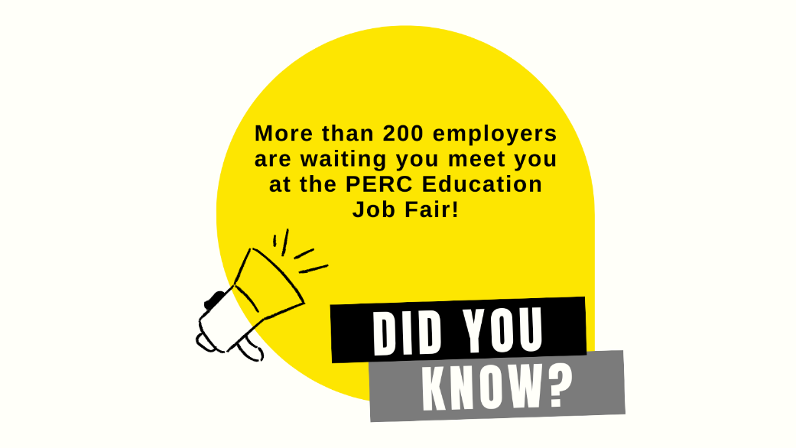
- Employers indicate job fairs provide a way for them to meet qualified and #motivated candidates! If that’s you, Sign up for the #PERC2023 Education Job Fair: http://bit.ly/3kQdfGH

Instagram Graphics

The following link provides Canva templates for promotional content that member schools can edit and customize for their Instagram feed: Content Templates

Caption: Mark your calendar for the #PERC2023 Education Job Fair. Priority registration opens January 30! http://bit.ly/3kQdfGH
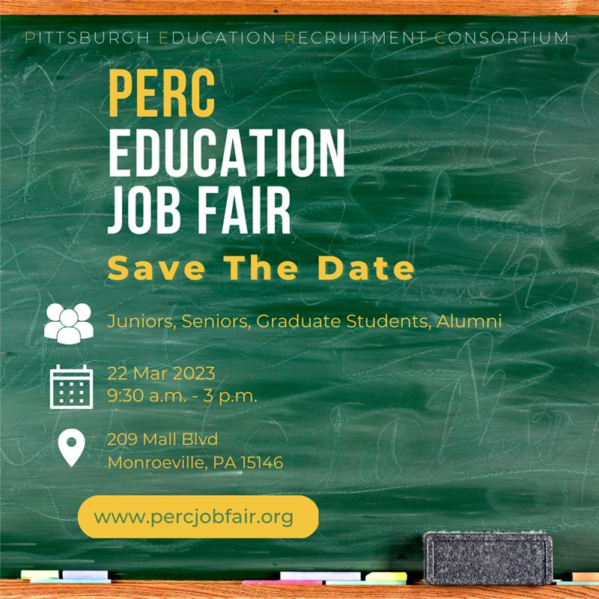
NOTE: include all for images to make ONE Instagram carousel post. Feeling creative? View the Canva Template to create your own version of this post or create other posts to promote PERC!
Caption: Pre-Register for #PERC2023 by March 17 http://bit.ly/3kQdfGH
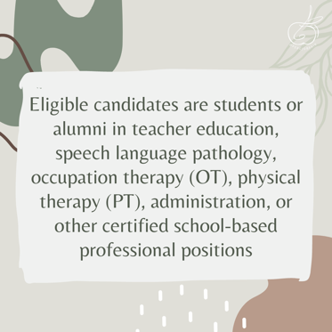

Facebook Graphics

The following link provides Canva templates for promotional content that member schools can edit and customize for their Facebook feed: Content Templates

Membership Workshop Opportunity

On Thursday, February 2, the PERC Executive Board is hosting a Zoom session at 2pm. We will be covering what’s new for 2023, reviewing how the interview area works, understanding the MCC Layout for this year’s event, sharing helpful event marketing tips, and answering your questions.
SIGN UP for the Zoom session by Wednesday, February 1! A video archive will be shared with everyone who pre-registers for the session.
Sincerely,
The PERC Marketing Team
Erin, Dorothy, Hailey, and Hanna

Marketing Emails
The following emails are available for PERC member schools to help promote the 2023 Education Job Fair. Feel free to adapt as necessary to meet your needs.

Member Schools

Dear PERC Member Schools,

We are pleased to announce that student registration for the Pittsburgh Education Registration Consortium (PERC) is now open!

Below follows information about the fair, along with materials you can use to market the fair to your students.

Date & Location
Wednesday, March 22, 2023
Monroeville Convention Center

Time: 9:30 a.m. - 3:00 p.m.
Eligibility
Registration is open to candidates who meet the following requirements:
- Juniors, seniors, & graduate students enrolled in a teacher education/administration certification program, OT/PT/SLP degree, school counseling, school social work, school psychology, school nurse or other school-based professional degree.
- Alumni who have graduated from either of the above programs.

Registration
Candidates can use the registration links contained in the attached marketing materials to register for the fair through the Handshake platform.

Please note: The fair will not be searchable in Handshake so candidates will need to use the link provided to access registration.

Student registration issues can be directed to Handshake Support and/or info@percjobfair.org.

Timeline & Fees

Candidates affiliated with Consortium Member Schools are eligible for priority registration beginning on January 30. On March 1, registration will also open to the public. Priority and general registration prior to March 17 are free of cost.
Same-day registration will cost $20 for candidates associated with consortium schools and $40 for non-affiliated candidates.

Marketing Materials

Attached to this message are various tools you can use to spread the word about the job fair to your students and faculty. Please feel free to customize the sample emails for your institution and/or audience.

Additionally, please take some time to follow and share our PERC Instagram with your student populations. We will use Instagram to share periodic updates, tips, and other helpful information with candidates.

Thank you for your membership in PERC - we are excited to put on another fair and see your students in March! Please feel free to reach out with any questions or concerns.

Sincerely,
Elisabeth Estes
Candidate Registration Officer, PERC
info@percjobfair.org

Candidates – Current Students

PERC Education Job Fair
Dear Students,

We are pleased to announce that registration for the Pittsburgh Education Registration Consortium (PERC) is now open!

The PERC Job Fair is a substantial annual recruitment event bringing together school districts and related education sector employers with current students and alumni in teaching and education-related fields.

As a student at <INSTITUTION>, you are eligible for priority access to register for the fair from January 30 – March 1. Registration instructions are below, and for job fair tips and more information we invite you to visit the PERC website.

Candidates who register early will be entered in a drawing to win a professional padfolio!

Date & Location
Wednesday, March 22, 2023
Monroeville Convention Center
Time: 9:30 a.m. - 3:00 p.m.

Registration & Fees

The PERC Job Fair is free to all students who register prior to March 17. After that date, all candidates wishing to attend must register on site at the fair for a cost of $20.

- Create a free Handshake account

Please note: All students, regardless of where they attend, can sign up and use Handshake for free.

- Build a complete profile in Handshake

Make sure to include your resume as well as other relevant information. Many employers will use this profile to learn more about candidates prior to the fair, so you want to make a good impression! Check out these helpful articles to learn how to upload a document to Handshake and build your profile from your resume.

- Register to attend the fair

Please note: The fair will not be searchable in Handshake so you will need to use the link above to access registration.

If you run into registration issues, please contact Handshake Support and/or info@percjobfair.org.

Prepping for the Fair

For updates on employers attending the fair as well as useful preparation tips, please follow the official PERC Instagram. You can also check the PERC website periodically for updates.

Sincerely,
<CAREER CENTER NAME>
<COLLEGE/UNIVERSITY>

Candidates – Alumni

PERC Education Job Fair
Dear Alumni,

We are pleased to announce that registration for the Pittsburgh Education Registration Consortium (PERC) is now open!

The PERC Job Fair is a substantial annual recruitment event bringing together school districts and related education sector employers with current students and alumni in teaching and education-related fields.

As an alumni of <INSTITUTION>, you are eligible for priority access to register for the fair from January 30 – March 1. Registration instructions are below, and for job fair tips and more information we invite you to visit the PERC website.

Candidates who register early will be entered in a drawing to win a professional padfolio!

Date & Location
Wednesday, March 22, 2023
Monroeville Convention Center
Time: 9:30 a.m. - 3:00 p.m.

Registration & Fees

The PERC Job Fair is free to all alumni who register prior to March 17. After that date, all candidates wishing to attend must register on site at the fair for a cost of $20.

- Create a free Handshake account

Please note: All students, regardless of where they attend, can sign up and use Handshake for free. Please contact your institution’s career center directly for information on how to sign up as an alumni.

- Build a complete profile in Handshake

Make sure to include your resume as well as other relevant information. Many employers will use this profile to learn more about candidates prior to the fair, so you want to make a good impression! Check out these helpful articles to learn how to upload a document to Handshake and build your profile from your resume.

- Register to attend the fair

Please note: The fair will not be searchable in Handshake so you will need to use the link above to access registration.

If you run into registration issues, please contact Handshake Support and/or info@percjobfair.org.

Prepping for the Fair

For updates on employers attending the fair as well as useful preparation tips, please follow the official PERC Instagram. You can also check the PERC website periodically for updates.

Sincerely,
<CAREER CENTER NAME>
<COLLEGE/UNIVERSITY>

Faculty

PERC Education Job Fair
Dear Faculty,

We are reaching out with information about the Pittsburgh Education Registration Consortium (PERC) Job Fair and asking for your support in promoting the fair in your classes.

The PERC Job Fair is a substantial annual recruitment event bringing together school districts and related education sector employers with current students and alumni in teaching and education-related fields.

Juniors, seniors, graduate students, and alumni of <INSTITUTION>, are eligible for priority access to register for the fair from January 30 – March 1, and candidates who register early will be entered in a drawing to win a professional padfolio.

Date & Location
Wednesday, March 22, 2023
Monroeville Convention Center
Time: 9:30 a.m. - 3:00 p.m.

Registration & Fees
The PERC Job Fair is free to all alumni who register prior to March 17. After that date, all candidates wishing to attend must register on site at the fair for a cost of $20.

Registration information is being sent to all eligible candidate, but we hope that you will help us promote the fair by speaking to your students about the importance of attending the job fair for opportunities spanning from networking to on-the-spot job offers.

Thank you for your support of our students!

Sincerely,
<CAREER CENTER NAME>
<COLLEGE/UNIVERSITY>

Workshop Marketing Email

FACULTY ONLINE WORKSHOP

Dear PERC Members: The follow email can be sent to faculty inviting them to attend a workshop on Tuesday, February 7 at 2pm overviewing the PERC Education Job Fair. Feel free to personalize and adapt the email to work for you and your faculty!

Dear (faculty name):
This year, the PERC Education Job Fair is back in person with some new and exciting additions.
We invite you to attend a Zoom meeting on Tuesday, February 7 at 2pm. This workshop, specifically for faculty and staff, will share information about how to help your students prepare and what employers are currently looking for in candidates.
Pre-Register by Monday, February 6 at 4pm. You can also copy and paste the registration link into your internet browser: https://pennwest-edu.zoom.us/meeting/register/tJMpdeippz0jG91YbKbpTzHmQOohX2sub58F
In case you're new to PERC, the job fair features more than 200 school districts who are hiring Pre K-12 teacher candidates, speech language pathology, school counseling, social work, OT/PT, library science, and administration. While this job fair does provide an opportunity for candidates to connect with out of state school districts, several Pennsylvania schools are attending!
Also, a big change for 2023 is that we are now open for students in their junior year of a program to attend. The Zoom meeting will specifically focus on why this is good for your students and how to help ensure they have a positive experience.
We cannot give away ALL the job fair details in this email! Please pre-register to Zoom with us on Tuesday, February 7 at 2pm. Everyone who pre-registers will be emailed an archive of the session.
Sincerely,
Your Name

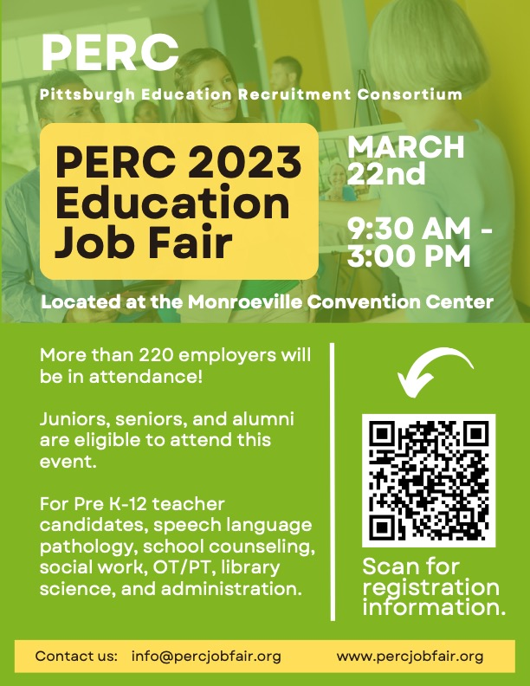
Download a printable PDF version of this flyer.

